



|  |  |
| --- | --- |
|  |  |
| **Project Name:** | Vehicle & People detection |
| **Client Name:** | Cummins SSNA DBU |
| **LOB Name:** | DT | IoT |

|  |
| --- |
| **Vehicle & People detection**  **Requirement Document** |

**Revision History**

|  |  |  |  |  |
| --- | --- | --- | --- | --- |
| **Version No.** | **Release Date** | **Author** | **Reviewed by** | **Overview of Changes** |
| 1 | September 6, 2022 | Divish R | Dhanashree Tayade | Initial Draft |
| 2 | September 15, 2022 | Divish R | Dhanashree Tayade | Pre-final Draft |
| 3 | September 15, 2022 | Dushyant & Rajat | Dhanashree Tayade | Indicative Azure BOM, Hardware specifications |
| 4 | September 16, 2022 | Divish R | Dhanashree Tayade | Final |
|  |  |  |  |  |

**Table of Contents**

1. Background 7

2. Scope 8

3. Out of Scope 9

4. Discoveries 9

5. Dependencies 10

6. Concurrence 10

7. User Roles 10

8. Requirements 11

8.1.Functional Requirements 11

8.2.Non-functional Requirements 13

9. High level Solution Overview 14

10. Indicative Screen Designs 15

10.1 Login Screen 15

10.2 Parking Yard Occupancy Screen 16

10.3 Servicing Bay Occupancy Screen 17

10.4 Parts Counter Occupancy Screen 18

11. Indicative Azure BOM 19

12. Hardware Specification 19

1. **Background**

**Business Problem**

Cummins Sales & Services North America’s Service Centers are located along the length and breadth of the United States of America. There are many facilities that serves its customers on a regular basis. In the pursuit of serving its customers more effectively, the division is encountering certain impediments that are listed below,

* Cummins Service Centers are unable to track the vehicle servicing bay occupancy, exact footfall of customer, peak servicing hours, servicing vehicle locations, customer uptimes etc.
* As its manually tracked, it is increasingly difficult for Service Centers to provide accurate servicing, delivery timings to customer, reasons for delay in delivery and hence scheduling issues are witnessed
* The Service Centers couldn’t compute the exact staffing required at various timings and unable to assign break schedules for the staff due to lack of data
* Centralized teams in Cummins find it difficult to analyze and interpret data from Service Centers across USA

**Proposed Solution**

The vision of this program is to build a **cutting-edge scalable digital solution** integrating smart devices and **Microsoft Azure Custom Vision Platform** that empowers Cummins team to detect People & Vehicle Occupancy, **better planning of work and scheduling of customer appointments** at various Service Centers across USA which in turn helps Service Centers to reduce cluttering of people in Parts & Service Counter areas.

This provides a hassle-free customer experience as Service Centers can schedule **exact servicing, delivery times** which effectively drives the brand value of Cummins in After sales division.

We intend to develop **custom dashboards** for the Service Center manager to have a check on day-to-day operations as it supports to **job planning, staffing, identifying peak hour traffic, determining break schedules** and remotely to assist the Cummins centralized teams with near real time visibility to branch capacity.

There are the two focus areas / bucketed use cases that our Digital Strategy will focus on,

* **Detecting Vehicles in Servicing Bay/Parking Yard Area**
  + *Detect number of vehicles in the servicing bay*
  + *Detect number of vehicles in the parking yard*
  + *Read the Unit number of the vehicles at Entry gate (Mostly on Non-driver side)*
  + *Generate Auto event & Capture Time Stamp*
* **Detecting People in the Parts & Service Counter**
  + *People occupancy detection in Parts & Service Counter Area*
  + *People Count, Timestamp & waiting time (Exit Time- Entry Time)*

1. **Scope**

This section briefs about the responsibilities and deliverables of Birlasoft in this project.

* Requirement Analysis and compiling the Business Requirement document based on regular interactions with the respective SPOCs from CSSNA
* High level Design document preparation & to be shared with CSSNA officials for Sign-off
* Development & Production Environment Creation
* Finalization of the IoT Sensors & Camera - Make & Model
* Design & Develop Application & Vision-AI Models for detecting cars in bays, people inside service centers
* *IoT Edge Device Software Development to send information to cloud*
* *Application Front End UI Development – Global & Facility level Dashboard, Drilldown to specific details (refer Point Nos. 8 and 10)*
* *Develop Restful web API & Database consideration*
* Azure Infrastructure Deployment (Alpha, Beta, Dev & Production Process)
* Support Cummins team for Hardware Installation & integration Testing
* UAT | Go-Live | 1 Week Hypercare Support
* Support Cummins Team for AMC & Rollout to other facilities
* Most of the vehicles are possessing the Unit IDs as they belong to a particular fleet and there are certain exceptional cases. We need to check the majority positioning of these Unit IDs in vehicles. All these Unit IDs are available in Cummins BMS (Vehicle Unit ID is detected only if its present in the vehicle). In PoC phase, BMS data integration is not considered in scope.
* The Scope for the Proof-of-Concept phase for both use cases are mentioned below
  + **PoC Scope for Use case 1 -** *Vehicle detection in Parking Yard & Servicing Bay area*
* *We intend to deploy Wireless Vehicle Detector & Camera & Vision-AI*
* *No of Vehicles - 6 Nos.*
* *No. of cameras – 2* Nos. & No. of sensors (TBD)– 6* Nos.*
* *Location – Cameras (1 at Entry Gate & 1 pointing the Parking Yard) & Sensors at the Servicing Bay*
  + **PoC Scope for Use case 2** - *People detection in the Parts & Servicing Counter area*
* *We intend to deploy Camera & Vision AI*
* *No of Cameras – 1* No.*
* *Location – Parts & Service Area Counter*

*\*Nos. will be finalized post the site visit in Discovery phase*

1. **Out of Scope**

This section mentions the items in this project that doesn’t come under Birlasoft’s responsibility.

* Customers who are entering the at the Cummins Richmond Service Center with their cars might not be tracked at the entry gate & their customer ID will be created only when they enter the Parts & Service counter area
* BMS Integration with Web application portal to fetch vehicle and customer related master data
* Mapping of the customer servicing delay reason with the fault codes or the unit IDs
* As we are not recording any live data, the integration of the live recording supervision screen with the web application and embedding live screens in the dashboards is not in scope
* Pushing escalation E-mails to higher levels of managers due to longer waiting times of customer
* Once the servicing bill is generated for the customer, CSSNA employee must manually close the waiting time of the customer in the system. Integration with invoicing system is not in scope.
* Notifications for external hazards, site shutdown etc. from Web Application
* Provision of L1 support
* Application hosting, backup, recovery and data archival or purging
* Azure PaaS Services Administration, Maintenance and support for any server or hardware
* Installation and configuration of any software framework in end user machines at the Cummins Richmond Service Center
* Disaster Recovery / Hardware Sizing / System Assessment / Training
* Network and Third-party security software installation, administration, and configuration
* Microsoft Azure Environment & other Licenses of are not in scope
* Hardware (Azure Edge device, IoT gateway, sensors, cameras, power supply) Engineering, Procurement & Installation at the Cummins Richmond Service Center is not in Scope
* Enhancement / development of applications in old versions of Microsoft software (Ex: Classic ASP) and .NET framework which are no more supported by Microsoft
* Any Software Application Tool licenses
* Integration with any other third-party business application is not in scope

1. **Discoveries**

* The technical team of Birlasoft and Cummins can also check on the feasibility of integrating with the existing cameras, positioning of new cameras at Cummins Richmond Service Center
* As the parts & the service counters are available in the same area and has got distinct queues, we can check on assigning different sets of entries and identifying the respective head counts
* For identification of status of the devices and cameras, it is suggested to have a dashboard displaying the active(connected)/inactive(Not connected)/last data captured information (time) of these items and need to check the viability
* The frequency with which the data is displayed will be based on the bandwidth availability
* Any obstacle in the field of detection of Entry gate camera will hinder the creation of vehicle Unit ID in the system

1. **Dependencies**

* Cummins Richmond Service Center needs to ensure the site readiness (slot markings and lightings in the Parking Yard, Servicing Bay, Parts purchase counter etc.)
* Cummins will provide the SMTP details for E-mail integration, if its required
* Apart from the existing security cameras, Cummins SSNA has to procure new cameras to be fitted for this project, however the type, specification (Make & Model) of cameras to be purchased will be mentioned by Birlasoft
* Cummins Richmond Service Center needs to provide the existing images (as per Birlasoft’s requirements) of the Parking Yard, Servicing Bay and Parts counter Area to train the ML model developed by Birlasoft
* Cummins needs to provide new and updated styling guidelines (if any) to be followed for the development of the Web application
* In the Web application, the Customer IDs will be available against the Vehicle Unit ID only if its present in the Business Management System of Cummins
* All network connectivity will be provided by Cummins (Ethernet, Wi-Fi etc.)
* Hardware (Azure Edge device, IoT gateway, sensors, cameras, power supply) Engineering, Procurement & Installation at Cummins Richmond Service Center will be provided by Cummins

1. **Concurrence**

* Entry & Exit Triggers for Servicing operation - When the truck enters, Camera at the entry gate will read Unit ID on the truck & an entry will be done in the application, waiting time starts & changes the occupancy % accordingly. Post completion of activities and bill generation, CSSNA employees need to manually close the time against the entry
* Entry & Exit Triggers for Parts purchase operation – When the customer enters the Parts counter area, the camera will create an entry & change the occupancy % accordingly
* Alerts and Alarms for excess occupancy % will not be provided for Servicing Bay occupancy limits or Parts Counter Area occupancy limits and only for Parking Yard occupancy limits

1. **User Roles**

|  |  |  |
| --- | --- | --- |
| **SL No.** | **Role** | **Description** |
| 1 | Cummins Administrator | This user will have access to complete application along with master data where they can add/edit/delete the information required for web application |
| 2 | Regional Manager | This user will have access to application for the sites which are under his portfolio and can add/edit/delete the information required for web application |
| 3 | Site Manager | This user will have a read only access to the application by which they can view the site-specific dashboard and reports |

1. **Requirements**
   1. **Functional Requirements**

* Detecting the incoming, outgoing and parking occupancy of vehicles in the Parking Yard at Cummins Richmond Service Center
* Detecting the incoming, outgoing and servicing occupancy of vehicles in the Servicing Bay at Cummins Richmond Service Center
* Detecting the incoming, outgoing and waiting time of people in the Parts & Service Counter Area at Cummins Richmond Service Center
* Role based data visualization (Cummins Administrator, Regional Manager, Site Manager)
* Login
  + Azure Active Directory integration
  + Login with Cummins WWID
* Development of a Web Application containing
  + - Dashboard 1 – Parking Yard Vehicle occupancy detection
      * *No. of alarms and alerts raised over a period of time*
      * *Parking Yard Total occupancy & Section wise Yard occupancy*
      * *Representing the slots filled and slots available*
      * *Time series graph of Parking Yard occupancy*
      * *Table with customer ID, entry time and waiting time*
      * *Two-dimensional Facility Map (Top view) for indicating Yard slots filling*
    - Dashboard 2 - Servicing Bay Vehicle occupancy detection
      * *Servicing Bay Total occupancy & Section wise Bay occupancy*
      * *Representing the slots filled and slots available*
      * *Time series graph of Servicing Bay occupancy*
      * *Table with customer ID, entry time and waiting time*
      * *Two-dimensional Facility Map (Top view) for indicating Bay slots filling*
    - Dashboard 3 – Parts & Service Counter Area occupancy detection
      * *Parts & Service counter area total occupancy*
      * *Representing the present footfall & accommodation available*
      * *Time series graph of Parts & Service counter area occupancy*
* Report Functionality Alerts/Alarms on Web application for excess occupancy in Parking Yard only (80+%)
  + - User will receive a pop-up notification in the application when any occupancy value crosses threshold limit set in master
* Report generation on a daily basis with the following parameters
  + - Volume (Footfall) for servicing requirements, Occupancy levels of Servicing Bay and Parking Yard, Time frames for servicing the vehicle
    - Volume (Footfall) for part purchasing requirements, Peak times of sales
* Custom Masters
  + - In the master’s, user has access of administrator to perform add, edit, and delete operations or different master data page (forms)
    - Master forms for –
      * User Creation (Add and Edit form)
        + WWID
        + Username
        + Active/Inactive (Checkbox)
        + Site Selection (Multiple Selection)
        + Role Selection
        + Submit/Update Button
      * Region and Site Master
        + Addition of New Region
        + Update existing Region
        + Addition of New Site
        + Update existing Site
        + Tagging of multiple Sites with Region
        + Submit/Update Button
      * Shift Calendar (Need to confirm from where Shift data can be fetched, or manual entry is required using form, if manual entry is required then Shift Calendar will have following fields)
        + Site Selection (Dropdown)
        + Month Selection
        + No. of Shifts
        + Shift Timings (From and to)
        + Holiday Date Entry (Calendar selection)
        + Submit/Update Button
      * Role Creation and Access Management
        + Add New Role (3 roles are considered 1. Administrator, 2. Regional Manager and 3. Site Manager)
        + Assign required Dashboard and Reports access to role
        + Submit/Update Button
        + This master access will remain with Administrator only
      * Alerts Master
        + Define Type of Alert
        + Select Alert Parameter (Currently considered only one as ‘Parking Yard Occupancy’)
        + Define maximum threshold limit in %
        + Select Role
        + Active/Inactive status
        + Submit/Edit Button
      * Vehicle ID Data
        + Need to consider BMS integration to get Vehicle ID data
      * Occupancy Master
        + User will have provision to enter

Maximum Number of parking lots in parking Area

Number of servicing lots in servicing Area

Maximum Capacity of Customer waiting Area (In Numbers)

* For Alerts Communication Only Pop-up notifications will be given, Email Communication is not required
* IoT Gateway will send the data collected from sensors to Azure IoT Hub at set frequency. This collected data will be stored in Azure database after passing through Stream Analytics / Azure Functions
  1. **Non-functional Requirements**
* Dashboard will be auto refreshed at periodic intervals and latest data after refresh will be displayed on the application (The intervals are based on bandwidth)
* Data sending frequency from IoT gateway to Azure IoT Hub will be at periodic intervals (The intervals are based on bandwidth)
* SNOW Ticket Generation for Application exceptions
* All the events will be pushed into the data lakes (post PoC phase)

1. **High level Solution Overview**

**Description about the Architecture :**

The data from the source will be collected through cameras and parking sensors installed at the site. The Parking sensor will detect the presence of cars in the parking area and send occupancy details to Edge hub. The cameras will also be connected to the Edge hub device and the images captured by the camera will be processed in the edge device itself. We make sure that no Images will be shared outside the Edge device and no images will be stored in the edge device.

The IoT Edge hub or Agent will connect to the Azure IoT hub and will only share messages related to occupancy of Humans inside the building and occupancy of cars in the parking area. The Azure IoT Hub will share information related to parking and occupancy in an application where a time series data will be maintained in an Azure SQL database.

The Azure Function will be responsible for aggregating data and generating reports for the application users. The Azure Function will also be responsible for generating alarms and alerts and sending emails through Service Bus if particular parameters crosses the threshold values.

The application users will be able to access the application through secured Azure Web Application Firewall (WAF) and Azure Application Gateway which will form a virtual network for the web application inside Azure cloud. Cummins WWID will be used for authentication and authorization into Azure cloud.

1. **Indicative Screen Designs**

Please find below the indicative screens that are developed to provide a high-level idea about the UI of the Web Application. The original Web application interface could be different from these screens

**10.1 Login Screen**



|  |  |
| --- | --- |
| **Accessed by** | Administrator, Regional Manager, Site Manager |
| **Description** | This screen will have the Login option only as Cummins credentials can be used to access this application if the ID is available in the Active directory |

**10.2 Parking Yard Occupancy Screen**

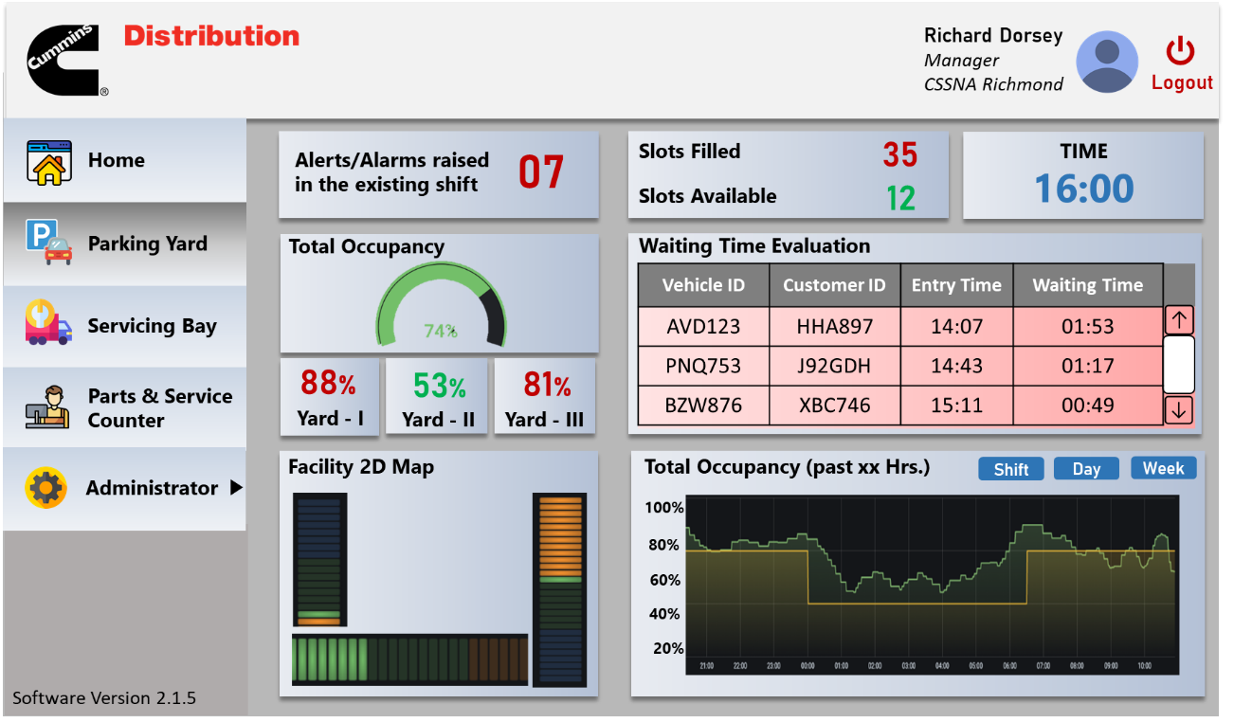

|  |  |
| --- | --- |
| **Accessed by** | Administrator, Site Manager |
| **Description** | Parking Yard Screen will have widgets for indicating   * *No. of alarms and alerts raised over a period of time* * *Parking Yard Total occupancy & Section wise Yard occupancy* * *Representing the slots filled and slots available* * *Time series graph of Parking Yard occupancy* * *Table with customer ID, entry time and waiting time* (based on BMS data) * *Two-dimensional Facility Map (Top view) for indicating Yard slots filling* |

**10.3 Servicing Bay Occupancy Screen**

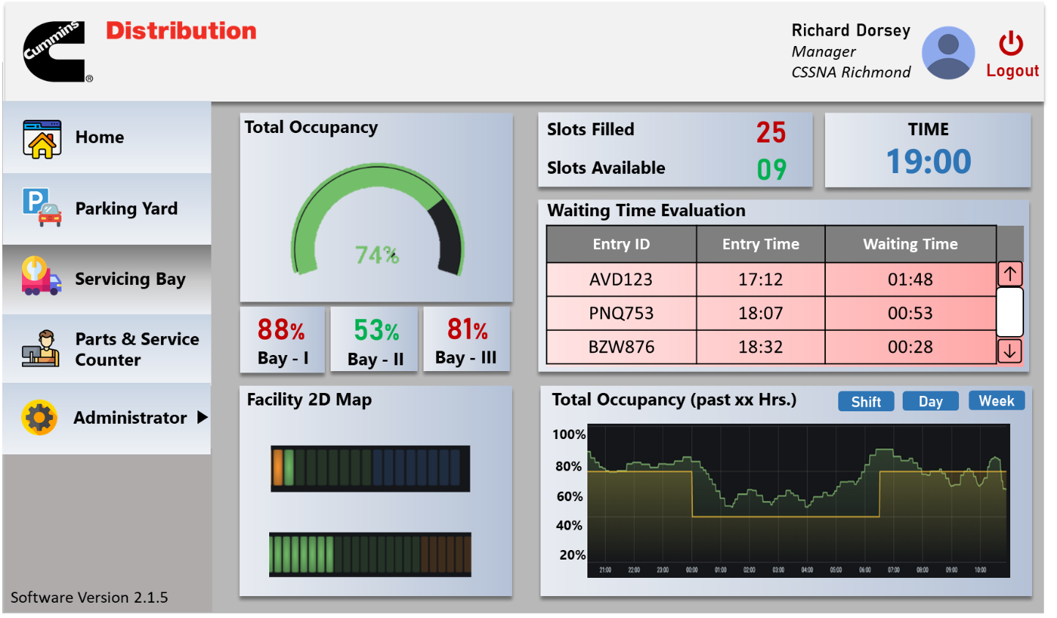

|  |  |
| --- | --- |
| **Accessed by** | Administrator, User |
| **Description** | Servicing Bay Screen will have widgets for indicating   * *Servicing Bay Total occupancy & Section wise Bay occupancy* * *Representing the slots filled and slots available* * *Time series graph of Servicing Bay occupancy* * *Table with Entry ID, entry time and waiting time* * *Two-dimensional Facility Map (Top view) for indicating Bay slots filling* |

**10.4 Parts Counter Occupancy Screen**

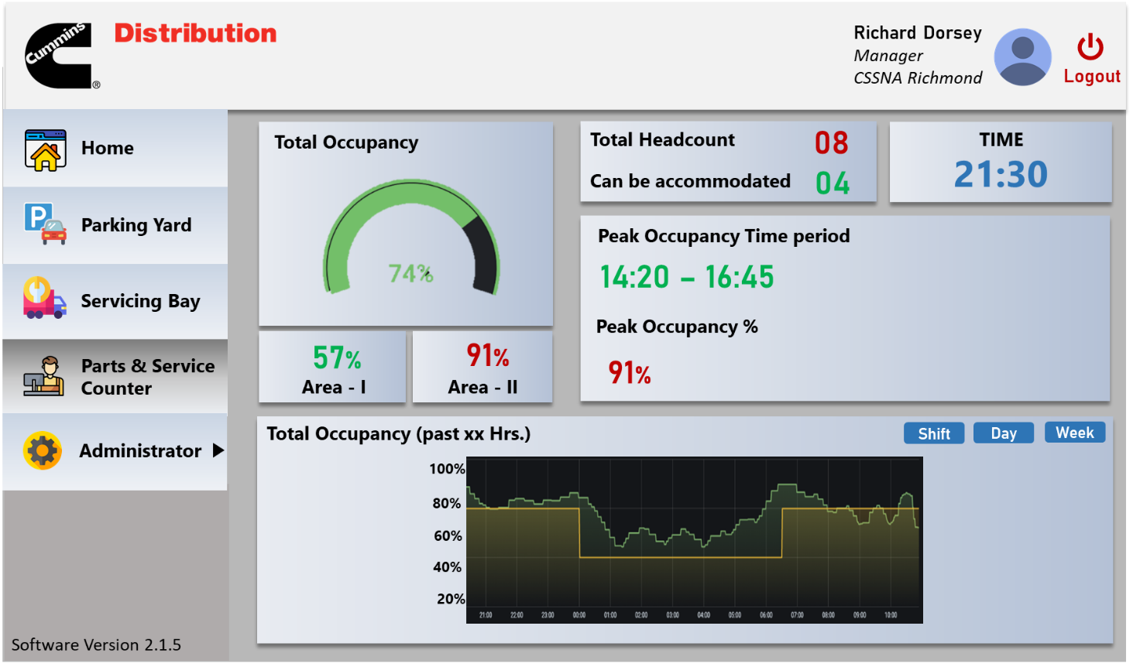

|  |  |
| --- | --- |
| **Accessed by** | Administrator, User |
| **Description** | Parts Service Screen will have widgets for indicating   * *Parts & Service counter area total occupancy* * *Representing the present footfall & accommodation available* * *Time series graph of Parts & Service counter area occupancy* * *Peak occupancy time period & occupancy* |

1. **Indicative Azure BOM**

|  |  |  |  |
| --- | --- | --- | --- |
| **Service type** | **Region** | **Description** | **Estimated monthly cost** |
| Azure Functions | East US | Consumption tier, 1536 MB memory, 600 milliseconds execution time, 500 executions/mo | $0 |
| Azure SQL DB | East US | Elastic Pool, DTU Purchase Model, Standard Tier, 100 eDTUs: 100 GB included storage per pool, 200 DBs per pool, 1 Pool(s) x 730 Hours, 5 GB Retention Clone​, 250 GB Storage | $246.02 |
| Azure Application Gateway | East US | Basic tier, Small Instance size: 1 Gateway hours instance(s) x 730 Hours, 0 GB Data processed unit(s) | $91.98 |
| Azure App Service | East US | Basic Tier; 2 B2 (2 Core(s), 3.5 GB RAM, 10 GB Storage) x 730 Hours; Windows OS; | $128.48 |
| Azure Key Vault | East US | Standard 1000 Operations on 24 hours | $0.03 |
| Azure Monitor | East US | 100000 standard API’s call per 24 hour | $1.60 |
| Azure IoT Hub | East US | Standard Tier, Unlimited devices, 4,00,000 msgs/day, IoT Hub Device Provisioning Service | $25.10 |
| Azure Stream Analytics | East US | 1 Streaming Unit x 730 hours | $81.30 |
| Azure Cognitive Services | East US | Custom Vision, Standard tier: 100 projects, 50 Hours training, 1,000 Image Storage transactions | $500.70 |
| Azure Data Lake | East US 2 | 1 TB Storage, 1 Read Transactions, 1 Write Transactions | $39.99 |
| Azure Container Registry | East US | Standard Tier, 1 registries x 31 days, 0 GB Extra Storage, Container Build - 1 CPUs x 1 Seconds - Inter Region transfer type, 5 GB outbound data transfer from East US to East Asia | $20.66 |
| Azure IoT Edge | East US | There are no charges to use Azure IoT Edge. | $0 |
|  | | **Total** | **$1,333.03** |

1. **Hardware Specification**

|  |  |  |  |
| --- | --- | --- | --- |
| **#** | **Hardware component** | **Area to be installed on** | **Nos** |
| 1 | IP based, Night vision Camera | Parking Bay | 1 |
| 2 | Sensor | Servicing Bay | TBD |
| 3 | Hardware component | Parts counter | 1 |
| 4 | Debian or Windows OS Box | Premise of Richmond Service Center | 1 |
| 5 | IP based, Night vision Camera | Entry gate | 1 |

**Note: Detailed specifications of the hardware components will be shared post site visit**